Insights from Wearable Device:

Stress patterns



Isabella Frid

EC Utbildning

Project in Data Science Oct 24

202410

# Abstract

In this study, we analyzed daily health metrics collected from wearable devices to identify patterns and correlations with stress indicators. Using data on heart rate, activity intensity, sleep duration, calorie consumption, and step count, we built a dataset to investigate how these variables interact and contribute to daily stress. A stress indicator was introduced based on heart rate data, providing a valuable measure for assessing high-stress days. Key findings reveal correlations between increased activity intensity, reduced sleep, and elevated stress levels. This analysis offers insights into how lifestyle factors relate to stress, which could inform personalized health recommendations.

Table of Contents

Abstract 2

1 Introduction 1

1.1 Background and theoretical frameworks 2

2 Stress and the Body’s Physiological Response 4

2.1 Wearables as Tools for Stress Measurement 4

2.2 Times and Daily Variations in Stress Levels 5

2.3 Summary of the Theory’s Relevance to the Study 6

3 Method 7

3.1 Data Collection 7

3.2 Agile Working Methodology 7

4 Results and Discussion 8

5 Summary 9

6 Självutvärdering 10

Source List 11

# Introduction

Stress is a growing health problem that affects both the physical and psychological well-being of people around the world. Research has shown that long-term stress can lead to a range of health problems, such as sleep disorders, cardiovascular disease, and a weakened immune system.

Psychologically, stress can lead to an increased risk of burnout, depression and anxiety, which in turn affects the quality of life and the ability to work. Given how widespread these problems are, it has become increasingly relevant to find new ways to monitor and manage stress levels in everyday life.

In recent years, technological developments have made it possible for the individual to collect health data in real time through so-called "wearables" — wearable technologies such as smart watches and fitness bracelets. These devices can track parameters such as heart rate, sleep patterns and activity level, all of which have a strong connection to the body's stress levels. By analyzing this data, we can gain valuable insights into how different factors affect stress, as well as identify patterns that can help us predict and manage stress before it reaches harmful levels.

The purpose of this report is to examine how wearable technologies can be used to measure and analyze stress, focusing on how heart rate, sleep patterns and activity levels can be related to stress by answering the following questions;

1. Can high stress levels be predicted based on daily heart rate and sleep patterns?
2. What patterns can be identified in wearables data to enable real-time prediction of stress levels?

## Background and theoretical frameworks

Stress is a natural physiological and psychological response to challenges or threats in our environment. When we experience stress, the body's fight-or-flight system is activated, leading to increased levels of hormones such as adrenaline and cortisol, higher heart rate and other physiological responses. These reactions are important for short-term survival, but long-term stress, or chronic stress, can lead to serious health problems. This makes it important to be able to monitor and understand stress levels over time, not only to detect short-term spikes, but also to identify and prevent long-term stress impacts on health.

According to Yale Medicine, the most common conditions caused by chronic stress is:

**Diseases: Addictions Mood disorders:**

Hypertension Alcohol Anxiety

Diabetes type II Nicotine Depression

Obesity Prescription drugs

Heart disease Food

Gambling

Recent years' technological developments in wearables have opened up new possibilities for continuous and non-invasive monitoring of physical markers. Wearables can measure parameters such as heart rate, sleep quality, and physical activity, giving us access to real-time data that was previously difficult to collect. In a research context, wearables have become a useful tool for studying stress and related factors. Heart rate and heart rate variability (HRV) are two common markers used to assess stress levels, as they provide information about how the body's autonomic nervous system reacts to different situations. HRV has been shown to decrease when stressed and give a clear indication of the body's adaptation to stress, while higher average heart rates may reflect increased strain.

By analyzing data from wearables, we can get a picture of how stress varies throughout the day and how a person's lifestyle, sleep habits and activity levels interact with their stress levels. This can lead to insights into what times of the day a person tends to experience higher stress and how these patterns can be affected or mitigated. Research has already shown that wearables can help detect early signs of stress and empower users to implement lifestyle changes or use stress management techniques.

This report observes how wearables can be used to collect and analyze physiological data to identify times of the day when stress levels are at their highest. By analyzing heart rate data from wearables throughout the day, we aim to shed light on how daily activities and habits can affect a person's stress levels and identify potential patterns or trends.

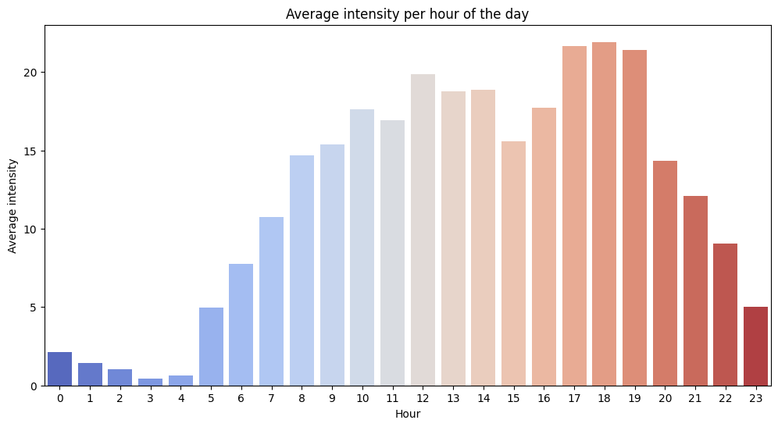

Figure 1 - Average intensity per hour of the day

# Stress and the Body’s Physiological Response

Stress is often defined as a feeling of physical or mental strain that can arise from perceived demands or threats from the environment. Hans Selye, a pioneer in stress research, described stress as a universal reaction of the body, which he called "General Adaptation Syndrome" (GAS). According to Selye, the body goes through three phases when stressed: the alarm phase, the resistance phase and the exhaustion phase. During the alarm phase, stress hormones such as adrenaline and cortisol are secreted, resulting in increased heart rate, blood pressure and muscle tension. If the stress becomes chronic, the body can move into the exhaustion phase where the increased stress load leads to negative health effects.

An important tool for measuring the body's response to stress is heart rate and heart rate variability (HRV). HRV measures the variations in the time between heartbeats and is an indicator of the balance of the autonomic nervous system (ANS), which controls the body's involuntary functions. At high stress, HRV drops, reflecting an imbalance between "fight-or-flight" and the "rest-and-digest" nervous systems.

## Wearables as Tools for Stress Measurement

Wearables have revolutionized our ability to follow the body's physical changes in real time. By continuously measuring heart rate and HRV, these devices enable a deeper understanding of the body's response to various daily activities and stressors. Several studies have shown that wearables can identify stress levels by analyzing changes in heart rate and its variations over time. One example of this is, that an elevated heart rate over a longer period of time, or a continuously low HRV, can indicate an elevated stress level in the individual.

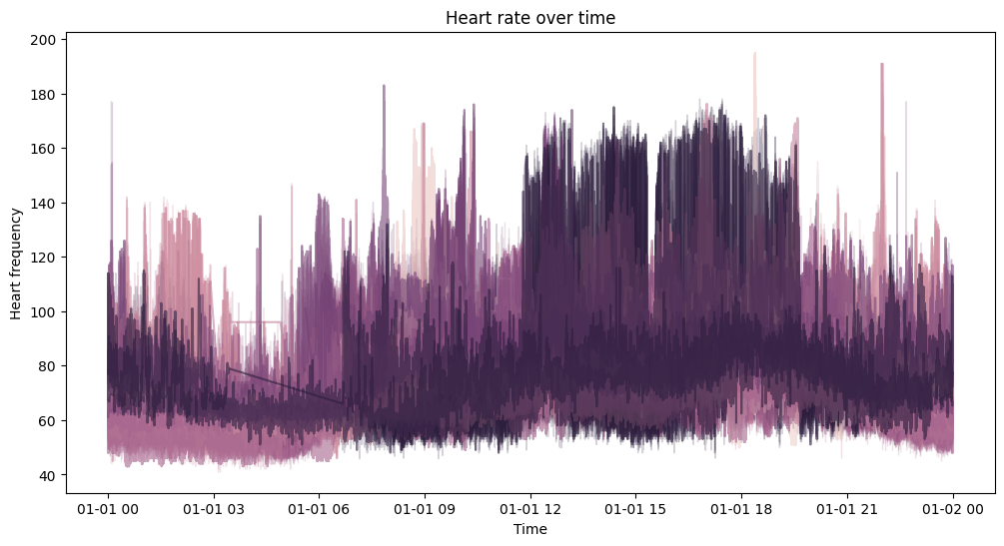The technology behind wearables is often based on photoplethysmography (PPG), which is an optical method where light is sent through the skin to measure changes in blood flow. PPG technology, which is used in many commercial wearables, has been shown to be accurate enough to provide reliable measurements of heart rate and HRV during everyday activities. Research into the use of wearables for stress measurement has also shown that these devices can help identify patterns of stress and even predict periods of increased stress by observing past patterns and trends in the user's data.

Figure 2 - Heart Rate over time

## Times and Daily Variations in Stress Levels

The time of day has been shown to be an important factor in stress research. The circadian rhythm, the body's internal circadian rhythm, affects many of our physiological processes, including the stress response. Previous research has shown that many individuals experience higher stress levels in the morning and during working hours, while stress often decreases in the evening. Wearables make it possible to monitor such variations in real time, which can provide a detailed picture of a person's stress levels throughout the day and help identify when stress management strategies may be most needed.

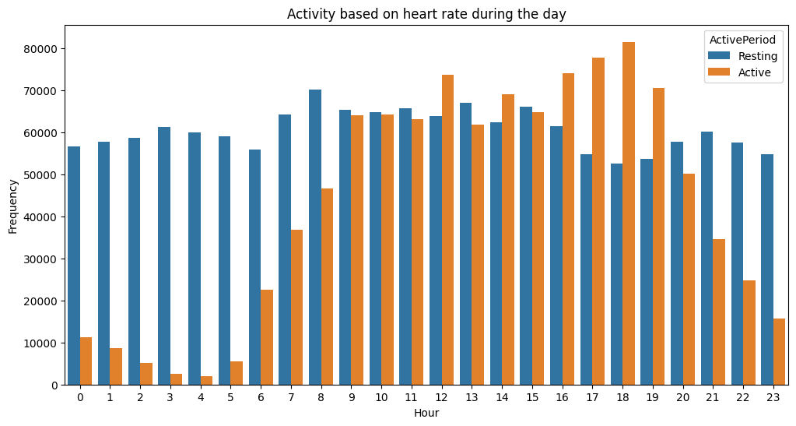

Figure 3 - Acitivity based on heart rate during the day

## Summary of the Theory’s Relevance to the Study

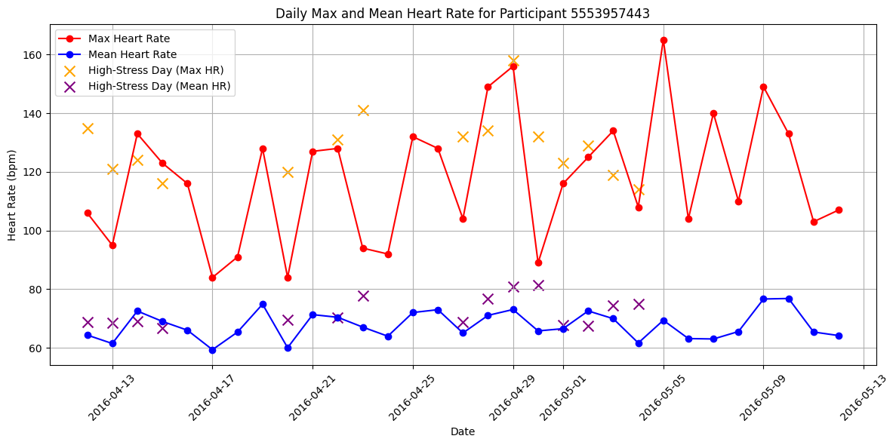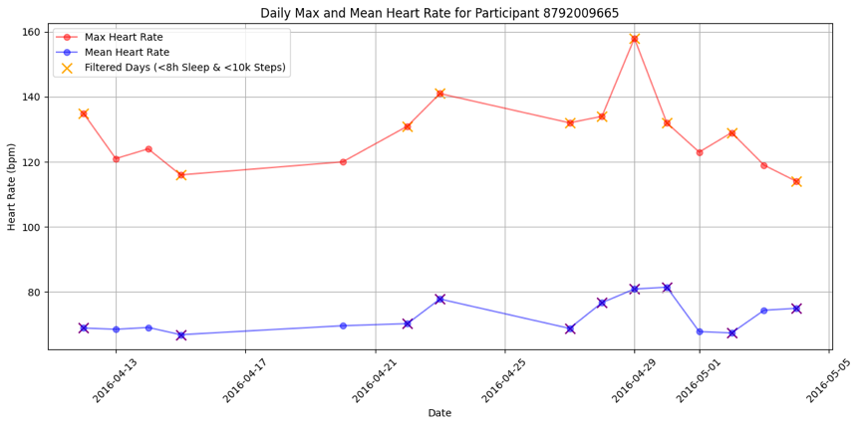By analyzing heart rate and HRV data from wearables, we can better understand how different times of the day affect stress levels in individuals. This study focuses on investigating how wearables can be used to create a detailed and dynamic picture of an individual's stress levels throughout the day. Wearables can help us create a model to identify periods of high stress and develop a better understanding of how everyday routines, sleep patterns and activity levels is affecting us.

Figure 4 - Daily heart rate on stressful days for ID: 5553957443

Figure 5 - Daily heart rate on stressful days for ID: 8792009665

# Method

This assignment was part of a group project and I was responsible for the data. I started with my good friend Google, and it didn’t take long until I found out that Kaggle was a great source for finding the data I was looking for. Many studies have been done within this area, and with the search “Fitbit Fitness Tracker Data” I got 204 results full with datasets ready to use. I can’t say I looked through all of them, not even a lot, but when I came across the datasets with over 150 000 downloads I was sold. The datasets had two different types of data, and I went with the most useful one – in my opinion – which included 14 different measurements for 31 people during a one-month period.

Since this was data that already has been used for studies there wasn’t that much cleaning that needed to be done, and I decided that 9 of these datasets would be useful for the whole group, whether it was for modelling, visualizations or to work on in Power BI.

I converted time, date and some values to be easier read, and made a merged Dataframe from 7 of the datasets. I saw that there wasn’t data for all dates for all the people and I decided to remove every row that had at least one missing value. This left me with data for 12 people and 31 days.

## Data Collection

The datasets from Kaggle was collected by a survey made by Amazon Mechanical Turk between the dates 12/3-2016 and 12/5-2016. A total of 31 Fitbit user consented and was accepted to share their personal tracker data, and manually registered values that can’t be measure with a fitness bracelet such as weight and BMI.

## Agile Working Methodology

As part of working with an agile mindset we agreed to use Trello as a tool to help us organize our project into a board. I broke down every single step we needed to do to make this project as successful as possible and I put each member to their assigned tickets. I also sorted every ticket with numbers so it would be easy to see in what order they needed to be done before we could go on with the next steps. The tickets were then sorted into different columns, “To Do”, “On Progress”, “Done” and “Evaluation” and the idea was to make a comment in the ticket every time it moved to another column.

We would also book meetings to follow up our work and to see if anyone needed any help with their tasks. In theory this idea was good. In practice we had a hard time getting everyone on these meetings, and a big problem was that no one informed the rest of the group until hours after the meeting that they couldn’t join.

During the project we kept in touch over Teams chats, were we made room for changes and improvements from the rest of the group in our own work. I can’t say this was appreciated by everyone and misunderstandings were made. I explain more about this in my recorded evaluation over the groups work and engagement.

# Results and Discussion

The results show a clear relationship between elevated heart rates and periods of high stress, with sudden increases particularly outside of physical activity periods. This outcome supports existing research, which identifies heart rate and heart rate variability (HRV) as reliable stress indicators that mirror the body's immediate response to both physical and psychological stressors.

The sleep analysis highlights an inverse relationship between sleep quality and stress levels. Nights with longer, uninterrupted sleep tend to correlate with reduced stress the following day, reinforcing the thesis that poor sleep quality may intensify stress. Furthermore, during periods marked by high stress, I observed a noticeable decline in sleep efficiency, suggesting that wearables could potentially alert us during escalating stress and help users recognize when their stress levels becomes critical. These insights align with previous research, which demonstrates that insufficient sleep can increase stress levels, while heightened stress can disrupt sleep cycles.

Finally, this study indicates that machine learning algorithms could be trained to detect recurring patterns in wearable data that often precede high-stress periods. As a result, wearables may go beyond passive monitoring to actively provide insights into stress management. This capability could be valuable for preventing burnout and enhancing overall quality of life.

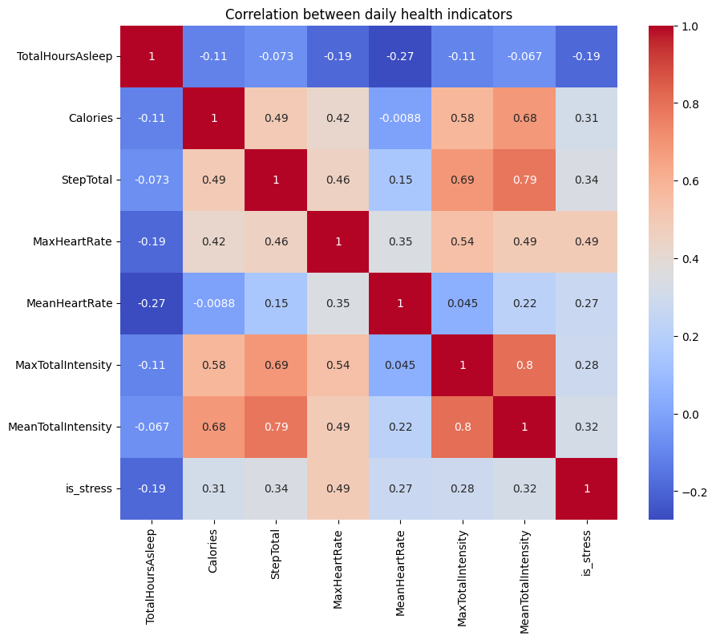

Figure 6 - Correlation between daily health indicators

# Summary

The results show a clear connection between high heart rate, abnormal sleep patterns and increased stress levels, which strengthens wearables as a tool to predict and monitor stress. My analysis answers both questions: wearables data can potentially be used to predict high stress levels and identify patterns that indicate stress in real time.

Although wearables data is proving to be a valuable indicator of stress, some limitations should be considered. Since stress can also be caused by emotional or environmental factors that are not always reflected in physical metrics, the precision of data collection can vary. To get more precise results we would need to include more parameters and improved algorithms to increase the accuracy of stress prediction based on wearables.

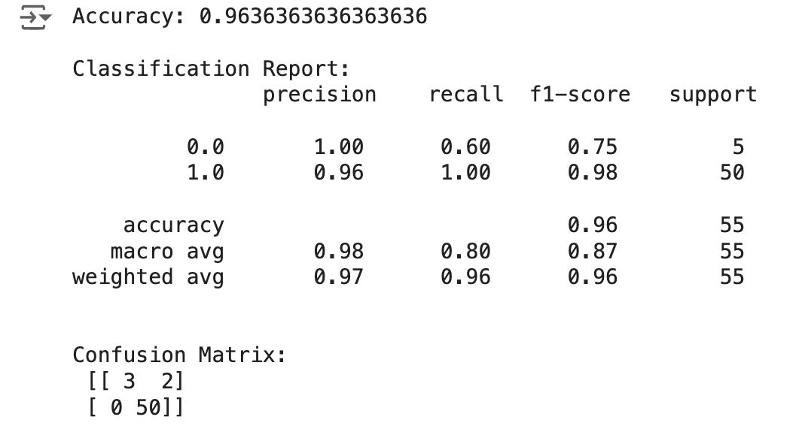

Figure 7 - Evaluation of my ML-model used in this analysis

# Självutvärdering

1. Utmaningar du haft under arbetet samt hur du hanterat dem.

* Den största utmaningen under arbetet har varit samarbetet med gruppen. Vi kommer överens om flera saker innan vi startar, men som sedan helt struntas i. Missförstånd dyker upp och när de klaras upp så görs fortfarande samma fel om. Ingen annan i gruppen än jag själv har påpekat tydliga problem som vi behöver lösa, men som även det struntas i. På grund av missförstånd att vi var 3 som skulle skriva koden tillsammans, och att jag valde att förbättra min del av koden, så har jag varit tvungen att skriva en hel kod på eget håll för att kunna stödja min teori i projektet – och för att kunna skriva denna rapport.

1. Vilket betyg du anser att du skall ha och varför.

* Jag hoppas att gruppens oengagemang i projektet inte drabbar mig negativt då jag känner att jag har gjort allting jag har kunnat göra för att försöka få det att funka. Jag hoppas därför att jag trots detta kan få godkänt i kursen.

1. Något du vill lyfta fram till Antonio?

* Vi ses i vår!

# Source List

Yale Medicine (year unknown). Chronic Stress.

<https://www.yalemedicine.org/conditions/stress-disorder#:~:text=Chronic%20stress%20is%20linked%20to,Type%20II%20diabetes%2C%20and%20arthritis>. (Retrieved 2024-11-01)

Web MD (year unknown). Heart Rate Variability.

<https://www.webmd.com/balance/stress-management/news/20240104/heart-rate-variability-anti-stress-weapon>. (Retrieved 2024-11-01)

MDPI (2023). The Future of Stress Management: Integration of Smartwatches and HRV Technology.

<https://www.mdpi.com/1424-8220/23/17/7314> (Retrieved 2024-11-01)

Healthline (2018). What Is General Adaptation Syndrome?

<https://www.healthline.com/health/general-adaptation-syndrome#stages>. (Retrieved 2024-11-01)

MDPI (2023). Photoplethysmography in Wearable Devices.

<https://www.mdpi.com/2079-9292/12/13/2923>. (Retrieved 2024-11-01)